Bay County Right to Life, 314 S. Jackson, Bay City, MI 48708, (989) 895.8481 FAX (866) 856.3918
E-mail: baycountyrtl@gmail.com http://www.baycountyrighttolife.org
~~~~~~~~~~~~~~~~~~~~~~~~~~~~~~~~~~~~~~~~~~~~~~~~~~~~~~~~~~~~~~~~~~~~~~~~~~~~~~~~~~~~

Victory for Michigan!!

The question of who pays for abortion insurance was answered in Michigan on December 11. The Michigan House (62-47) and Senate (27-11) approved the citizen-initiated Abortion Insurance Opt-Out Act. Michigan joins 23 other states in opting-out of abortion coverage in their health insurance exchanges through the Affordable Care Act, and elective abortion had been removed as standard 'benefit' from health plans. The NO Taxes for Abortion Insurance petition drive was democracy in action. In 120 days volunteer Michigan citizens from every county gathered more than 315,000 signatures to support this legislation. In Bay County many, many churches, businesses and individuals helped gather 7,038 valid Bay County signatures. Thank you Bay County for your strong show of support.

One issue that was raised during the petition drive was abortion in cases of rape. Bay County’s own Mary Rathke, took a very public stand on this issue. This is her story:

I was conceived in rape. I am proof that even after a horrible and terrifying encounter, a woman can not only choose life for her child, but also give a lifetime of joy from this decision. My life has been blessed in countless ways, and the story is in itself, miraculous. I have been blessed with two loving sets of parents. My adoption was open, and I never felt abandoned in any way. One set of parents loved me, cared for me, and nurtured me, and the other set of parents were my superheroes for making the right decision to relinquish my custody when it mattered the most. My birth parents knew the rape resulted in my conception but they still viewed me as child who deserved life. Only close family knew about the nature of my conception and I was not told until after my birth mother's husband, passed away in 2011. I was 32 years old when I knew the entire truth.

My birth mother suffered from mental illness and even though the state tried to
help her learn how to care for me, by the time I was five years old the decision was
made that the couple who had been caring and helping with me, would be able to legally adopt me. It was a restoration for my adopted parents. My adopted mother Ursula had lost 4 children in an accident, with only a surviving son. So through a tragic event as a rape, my life brought joy to an adopted set of parents and to my birth family. I am not an ugly reminder of one bad man, but rather I am a blessing for all those who know me.

But I am offended by the words and attitudes of abortion advocates and legislators who use people like us to defend abortion especially in health care. Abortion is not health care. To suggest that abortion should be covered in cases of rape says nothing more than a health insurance contract should be a contract on our lives. Think about it. In all of the debate about Obamacare, is any one arguing that insurance needs to be specifically provided to exterminate any other group in the population? For those of us conceived in rape this is not rhetoric. We are real people!

Memorials and Donations

We would like to thank the family and friends of Donald Shankin, and John Fuccillo for donating to BCRTL in their memory. We extend our most sincere sympathies.

2014 BCRTL Officers and Board Members

Lisa Goss, President David Studniarz, Board Member
Kathy Ratajczak, Vice President Richard Roberts, Board Member
Denise Davidson, Secretary Cheryl Campbell, Board Member
Elly Smyczynski, Treasurer Maribeth Hopps, Board Member

We would like to thank retiring secretary Gayle Roberts for her faithful years of service. A hearty welcome to Cheryl Campbell, Maribeth Hopps and Richard Roberts as new board members. We look forward to a very productive 2014!

Membership

One of the most effective and efficient ways to express your concern about abortion and rationing of care is to make your voice be heard as one of many. You can do this by joining Bay County Right to Life. As an affiliate of Right to Life of Michigan, we can educate the general public, assist pastors and religious leaders, share the prolife message with students and elected officials with one voice as to the value of life. There is strength in unity. Membership in Bay County Right to Life is due yearly. Turn your concern into action. Do your part. Become a supporter of the strongest prolife voice in Michigan and Bay County. Please send in your membership for 2014 today.

***********************************************************************************************************************************

BAY COUNTY RIGHT TO LIFE MEMBERSHIP FORM 2014

___ $100 (gold) ___ $50 (silver) ___ $25 (bronze) ___ $18 (family) ___ $12 (individual)

___ $8 (senior citizen) ___ $15 (senior couple) ___ $ (other gift)

____ I want to help. Please contact me. _____ Please remove me from your list.

Name _____________________________ Spouse ____________ Phone ___________________________

Address ________________________________________________________________________________

City ________________ Zip __________ Email ________________________________________________

Please make checks payable to: Bay County Right to Life, 314 S. Jackson Bay City, MI 48708. Gifts to or memberships in Bay County Right to Life are non-tax-dedictible for income tax purposes.

Bay County Right to Life News is published quarterly by: Bay County Right to Life, 314 S. Jackson, Bay City, MI 48708 E-mail: baycountyrtl@gmail.com; Phone: (989) 895-8481 Fax: (866) 856-3918, Winter 2014, Elly Smyczynski, Editor

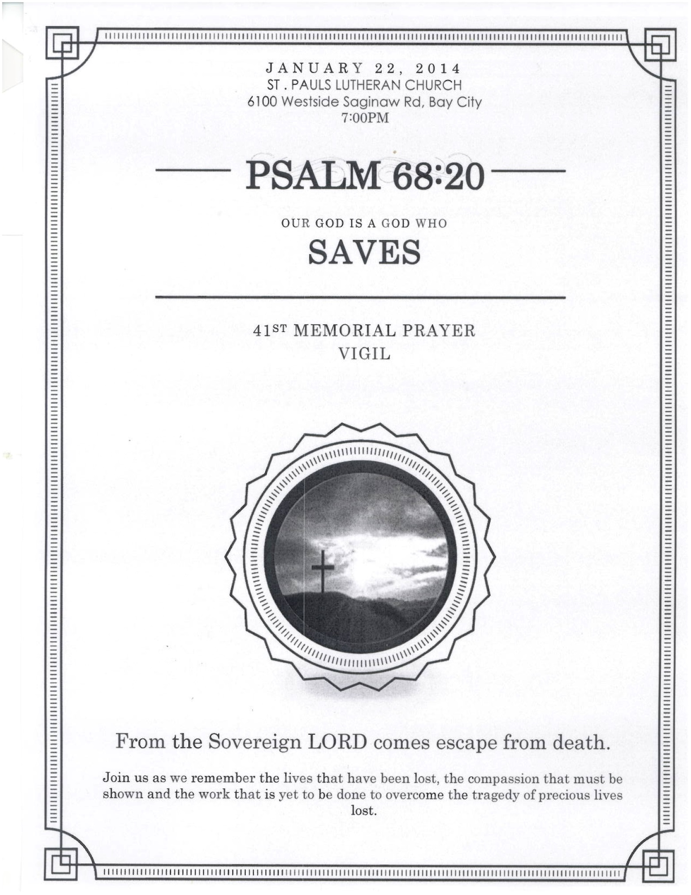

Calendar of Events

January 14 – General Meeting
Harvest Baptist Church, 7 pm

January 19 – Sanctity of Human Life Sunday

January 22 – Memorial Vigil, 7 PM
St. Paul Lutheran Church

February 11 – General Meeting

If you are online, check out our website, join our email network or "like" our new Facebook page. Educate yourself via the internet to keep updated on local, prolife events and news flashes. STAY INFORMED, STAY CONNECTED.

